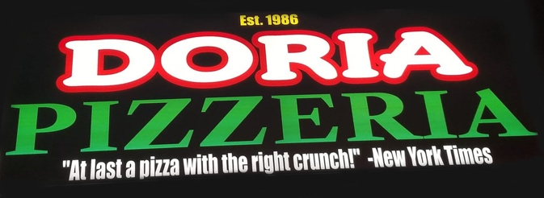

1 Large Cheese Pizza
1 Italian Salad
5 piece chicken wings

$35 total

